Reclaiming the Algorithmic margin Fintech - A Green Fintech Justice Matrix for Climate Finance in the Age of Frontier Technologies
Syed Nagul Meerabi¹, Venkateswara Kumar K S²
¹²KL Business School, Koneru Lakshmaiah Education Foundaion [KLEF], Vaddeswarm, Guntur, Andhra Pradesh, INDIA.
Corresponding Author, E-Mail Id: syednagulmeerabi@gmail.com
Orcid Id: https://orcid.org/0009-0002-5235-3783

Abstract:
AI credit scoring, decarbonisation enabled by satellite verified carbon markets, parametric climate insurance and tokenized green bonds are just a few of the potential ways green fintech could direct capital to decarbonisation. However, the same tech stack can be used to create a "green margin paradox": the communities most vulnerable to climate risk are not able to participate in climate finance, and their data is used without providing them with any value back. Governance discourses around this are typically oriented towards access gaps and the need to fill them through greater coverage and applications. Based on a conceptual synthesis of AI governance, sustainable finance, political ecology and Indigenous data sovereignty, we created the Green Fintech Justice Matrix (GFJM). The framework conceptualizes digital marginality as green algorithmic enclosure, which refers to the way that algorithmic systems encircle and capture the value of marginal communities' data and climate exposure, excluding them from the related financial rewards. We bring forth four measurable constructs: the Green Margin Gap, the Carbon Redlining Index, the Compute-Carbon Ratio [and Water counterpart] and the Algorithmic Green Sovereignty Score. We then introduce four institutional mechanisms by which the algorithmic margin can be recovered community protocol audits, green data trusts, carbon-budgeted models and algorithmic recourse. This pricing difference is 8.7 percentage points for low and high vulnerability borrowers, and is reduced to 2.1 percentage points by the GFJM governance, as illustrated in a simulation using synthetic borrower data. It brings a perspective of justice to climate-finance governance and a measurement agenda for regulators, lenders and communities, and recovers the social and financial edge at once.
Keywords: Green Fintech, Climate Finance, Algorithmic justice, Green Algorithmic enclosure AI governance.
1. Introduction: Reclaiming the Algorithmic Margin
Frontier technologies are playing a growing role in the intermediation of finance for climate change. Physical and transition risk pricing by machine-learning, carbon removal and avoided deforestation by satellite and computer-vision, and the use of distributed ledgers to document carbon bond provenance. The implication is that seemingly better computers will lead to better capital allocation to decarbonisation and adaptation. Algorithmic lenders discriminate less than face-to-face lenders, but they still discriminate against Latinx and African-American mortgage borrowers (Bartlett et al., 2022), and machine-learning credit models discriminate in favor of some racial and ethnic groups more than others (Fuster et al., 2022). Also, verification technologies can be flawed: voluntary REDD+ projects, for instance, have been shown to overestimate emission reductions (West et al., 2020).These findings are not for green credit, but rather consumer lending and carbon-offsetting. Whether similar patterns emerge when it comes to the pricing of climate finance is an empirical matter, one that is not assumed in this paper.
Algorithms do not affect climate-finance allocation equality; it is already unequal. The Panel evidence indicates that there is a relationship between investment readiness and increased funding for adaptation, with vulnerable regions like Sub-Saharan Africa and South Asia getting less funding than they deserve, and past funding predicting current funding, creating a “low funding trap” (Islam, 2022). A critical review also shows that climate vulnerability does not necessarily influence access to adaptation finance - institutional capacities and financial and political interests play a more important role (Venner et al., 2024). These studies are related to public climate finance. We wonder whether these same patterns emerge in the private sector, when data-driven instruments are used.
The tension that results we call the green margin paradox. The group of households, smallholders and micro enterprises at the highest risk of climate change are also the ones who face the highest price for risk, have the least data or most easily extractable, and where land and water provides the physical infrastructure for the digital economy (Couldry & Mejias, 2019; Zuboff, 2019). These systems have a carbon and water footprint that is challenging to quantify, as operators are not very transparent (de Vries-Gao, 2025) and this varies significantly based on server location (Xiao et al., 2025). Thus the margin is doubled; the social margin, the place of the marginalised people, and the financial margin, the margin of difference that determines those who can adapt. The spatial logic is reminiscent of the history of redlining, where a risk assessment framework has been used to exclude people from credit based on their place of residence (Rothstein, 2017). At the point where both margins connect, the scoring, verification and pricing layer where social position is turned into monetary values, is where we use algorithmic margin:
Not every difference in price based on risk is considered injustice by GFJM. Climate-exposed borrowers can have a valid higher cost of service. Instead, the framework focuses on disparities after accounting for objective climate, financial and operational risk, a similar approach to the one used for fair-lending analysis (Bartlett et al., 2022).
We question two assumptions of contemporary governance:
The Infrastructure Fallacy: Unequal access to green capital needs wallets and digital identity, but so does extending mobile coverage. In general, inclusion agendas focus on access measures rather than the conditions under which access is made available, like ownership of an account and digital payments (Demirgüç-Kunt et al., 2022). Include 1 or 2 statements of this assumption in policy documents.
There exists an objective arbiter: the Neutrality Fallacy of green-credit, ESG and carbon-verification models. Not all ESG scores are created equally (Berg et al., 2022) and algorithms with "incomplete" or "socially embedded" data can end up reinforcing the biases found in the data (Fazelpour & Danks, 2021). Credit-scoring models, automated ESG rating algorithms and opaque risk-assessment engines may demonstrate that these systems operate with limited human oversight, and the responsibility for their outputs appears spread across developers, data vendors and lenders. However, the ratings could indicate that these inputs remain unreliable: different ESG providers might assign that divergent scores emerge for the same firm, even when measuring the same construct (Berg et al., 2022). Moreover, the evidence may suggest that when such scores determine access to finance, a scored party could demonstrate inability to understand or contest the result. Nevertheless, the decision-maker might indicate that reliance on it appears necessary to allocate capital (Meerabi et al., 2026).
In this sense we contend that the digital marginality in green finance is not only an inheritance from the connectivity divide but also a creation of the design and deployment of the systems. We thus reframe it as green algorithmic enclosure and envision justice as an epistemic, ecological and financial necessity in climate finance. The paper has four contributions. First, it creates the Green Fintech Justice Matrix, which incorporates elements of AI governance, sustainable finance, political ecology and Indigenous data sovereignty (Carroll et al, 2020). Second, it brings in four measurable constructs: the Green Margin Gap, Carbon Redlining Index, Compute-Carbon Ratio and Algorithmic Green Sovereignty Score. Third, it outlines four interventions by which the algorithmic margin can be restored: community protocol audits, green data trusts, carbon-budgeted models and algorithmic recourse. Fourth, it illustrates a simulation—this is not an empirical estimate, but a simulation—whereby the pricing difference between low and high vulnerability borrowers goes from 8.7 to 2.1 percentage points with the addition of GFJM governance.
2.1 Green Algorithmic Enclosure:
Enclosure physically fenced and privatised physical commons. Studies of the data economy refer to another similar transition, where data is collected, consolidated and monetised (Sadowski, 2019). Proprietary green-finance models are also the walls of environmental and behavioral data commons. We name this green algorithmic enclosure as Green Enclosure. It is based on the concept of data colonialism (Couldry & Mejias, 2019), which draws on data being extracted and used as the evidence that establishes the value of the climate as an asset for sale on carbon markets and in the green-bond industry, but it isolates the specific mechanism: community-generated environmental data is both extracted and becomes the evidence for the climate value that is sold in the markets. Enclosure is the identification of the ones who control the monetization of environmental knowledge, while data colonialism refers to an extraction more broadly.
2.2 The Double Margin:
We hypothesis that social and financial marginality reinforce each other. The further away from the average, the greater the perceived risk is, the more difficult the adaptation is to afford, the higher the level of vulnerability is, and the next scoring cycle sees that vulnerability as higher risk. They restrict the life chances that they purport to measure (Fourcade & Healy, 2017), predictive systems can feed back into their own outputs (Ensign et al., 2018), and climate-finance allocation may demonstrate that path dependence appears in the form of a low funding trap (Islam, 2022). However, these literatures could suggest that the extension demonstrates that vulnerability might become self-reinforcing when algorithmic assessments both measure and reproduce perceived risk. Moreover, the proposition may indicate that this represents a theoretical claim rather than an empirical finding.
2.3 positioning GFJM with in Sustainable Finance Theory:
- Stakeholder Theory
What it means: A firm has a responsibility to all those that are touched by it or it is touched by them (Freeman, 1984), and shareholders are not the only ones. Mitchell and others (1997) expand the criteria for determining how managers prioritise stakeholders, specifying based on power, legitimacy and urgency. Legitimate but non-powerful stakeholders are left out of the picture.
Power is low in climate-exposed communities, who have a high stake in and legitimacy for the data, which creates the value being sold, as they are fitted with GFJM. In theoretical terms it is the “double margin.”
Why say it? Justifies community protocol audits, binding veto and green data trusts as means for turning legitimacy into power. It also establishes P3 (Trust of stakeholders is increased by audits, reducing the Green Margin Gap).

- Information Asymmetry Theory
This is because markets fail because of adverse selection (Akerlof, 1970), signaling (Spence, 1973) or credit rationing (Stiglitz & Weiss, 1981) when one party knows more than the other.
With GFJM: Lenders and verifiers own the model, the scoring logic and the data. Borrowers can't logically see why they are in such a price. Your own cited point, where ESG scores split, is an asymmetry problem (Berg et al., 2022). There's also the twist: Lenders have limited, if any, reliable data about vulnerable borrowers, which can lead to uncertainty being priced into the risk.
Because it's the primary economic theory why price gaps exist even if they are not intentional. It facilitates algorithmic recourse and counterfactual explanations as strategies to reduce asymmetry, and it also aids in the defence of the risk-adjusted GMG from the argument that it is simply rational to have higher prices.
- Resource Dependence Theory
That which it means: Organization’s rely on resources from outside, like capital, legitimacy and data. They adjust their actions to deal with that dependence (Pfeffer & Salancik, 1978).
If dependent, fit with GFJM: Dependence is two-way and it may be shown in the paper. Lenders and verifiers are the source of capital for communities. Communities are also critical for ground truth and land/environmental data for carbon markets and green-bond issuers. Hidden dependence is transformed into negotiating power by green data trusts and reciprocity based ledgers.
For why: It is because data sovereignty is a strategic resource and not just an ethical demand. It also has a connection to P4 (board green competence) since boards are a classic resource-dependence management channel for external dependencies.
- Institutional Theory
The point that is being made: Organization’s implement practices that are not only efficient but that gain legitimacy. Pressures come from regulation (coercive), imitation under uncertainty (mimetic) and professional norms (normative) (DiMaggio & Powell, 1983). Formal structures may turn into ritualized and become detached from reality (Meyer & Rowan, 1977).
Fit with GFJM: The theory of your “Neutrality Fallacy” and algorithmic greenwashing. Firms can use fairness statements, ESG labels and “responsible AI” checklists to ensure they are using AI in a legitimate way without changing the underlying costs and methods of pricing and extraction. It also provides an understanding of the concept behind the need for binding mechanisms, not voluntary codes.
So, why be explicit: It does help P5 (sovereignty reduces greenwashing exposure and enforcement risk) and you do have a criticism of “defensive ethics checklists”. It also informs you what mechanisms are needed to be supported by the regulators to prevent symbolic compliance.
- Climate Finance Theory
First of all, be warned that this is not a single, monolithic theory, but a collection of research on the ways in which climate money is raised, allocated and governed. If you state that it is “theory,” without qualification, it may be a red flag to a critical reader. I propose to refer to it as climate finance justice literature or climate finance governance.
What it covers: Distributive justice: who benefits from climate funds (Roberts & Parks, 2007), allocation based on institutional capacity rather than vulnerability (Islam, 2022; Venner et al., 2024) and critiques to how climate finance is designed and who benefits from it (Bracking, 2015).
Fit with GFJM: Your problem domain. It provides evidence of use – the “low funding trap” – and the normative argument that individuals least responsible for the crisis should not be paying the highest cost for adaptation.
Because of these reasons: If not, it might come across as the trivial application of AI ethics to the field of green finance.
3. The Green Fintech Justice Matrix (GFJM)
Why Existing Frameworks Are Insufficient is
Table 1.Brief comparison
Framework | Limitation
Responsible AI | Focuses mainly on fairness and transparency Jobin et al. (2019)
ESG Governance | Ignores algorithmic harms Berg et al. (2022),
Data Justice | Does not address climate finance Taylor (2017),
Political Ecology | Does not provide governance metrics Strubell et al. (2019), de Vries-Gao (2025)
GFJM | Integrates all four domains

The GFJM demonstrates that four analytical lenses may unify into one important intervention architecture (Figure 1). Moreover, the framework could indicate that movement beyond defensive ethics checklists appears possible. Furthermore, the evidence may suggest that each lens ties to a concrete pillar. Nevertheless, the data could show that a mechanism can be built. Framework links lens to measured index.
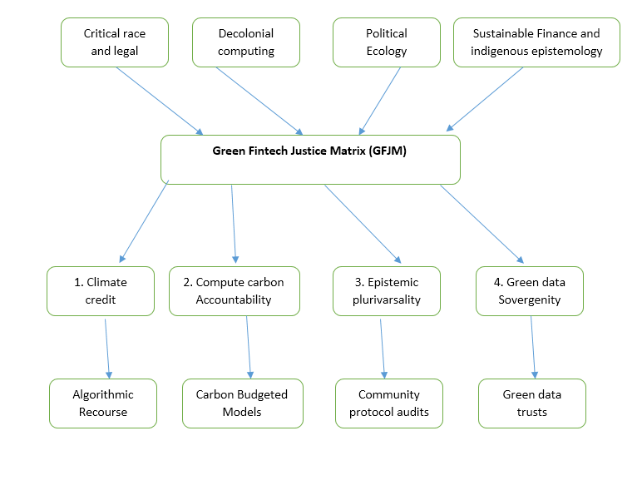
Figure 1. The Green Fintech Justice Matrix: lenses, pillars and mechanisms.
Source made by Author
Pillar | Core requirement | Intellectual root
1. Climate-Credit Reparations | Build historical power asymmetries into model design and reallocate decision authority and capital toward climate-exposed groups, instead of debiasing after training | Critical Race and Legal Theory; (1978-, 2019)
2. Compute-Carbon Accountability | Evaluate the full supply chain of any green-fintech stack, from mining to inference, and cap model footprint against the abatement it finances | Political Ecology; (Strubell et al., 2019)
3. Epistemic Pluriversality | Admit local, indigenous and community-held ontologies of risk and value as legitimate model inputs, not noise (Fricker, 2007) | Decolonial Computing; Mohamed et al. (2020)
4. Green Data Sovereignty | Separate identity from data; communities hold governance and licensing rights over data used to certify climate value | Indigenous data governance; STS

Table 2. The four GFJM pillars.
3.1 Testable Propositions:
 | Proposition | Boundary condition
P1 | Community-verified green transparency raises substantive ESG outcomes more than disclosure volume alone | Moderated by Regulatory Stringency
P2 | Green algorithms may improve green decision quality by strengthening ethical judgment among model owners, particularly where governance oversight mechanisms are present. | Mediated by Ethical Judgment
P3 | Community protocol audits increase stakeholder trust, which in turn lowers the Green Margin Gap | Mediated by Stakeholder Trust
P4 | Board green competence strengthens the effect of carbon-budgeted models on the Compute-Carbon Ratio | Moderated by Board Green Competence
P5 | Green data sovereignty reduces algorithmic greenwashing exposure, lowering litigation and enforcement risk | Strongest where data quality in the supply chain is high
Table 3 may indicate that the propositions appear to link GFJM to important organisational constructs.
Table 3 data is completely theory, which was obtained from (Freeman, Akerlof, Pfeffer & Salancik, DiMaggio & Powell)
The present study establishes that testable propositions connect the matrix to organisational research on green fintech. However, the findings suggest that five propositions could demonstrate key relationships through panel, experimental or case-comparative designs.

4. Operationalizing epistemic techno-justice
Each pillar pairs with an institutional mechanism, the results might indicate that Table 4 provides the key framework. Institutional mechanisms link pillars to measures. Additionally, Table 5 may suggest that measurable indices could establish that justice claims appear auditable in the way that capital-adequacy ratios are.
Mechanism | Stage | Design
Community Protocol Audits | Pre-deployment | Participatory action research with binding veto for impacted communities over green-scoring and MRV models used in public or subsidised programmes. Audit reports are published in local languages. Raji et al. (2020)
Green Data Trusts | Data ownership | Locally governed trusts hold copyright, governance and licensing authority over farm, forest and energy datasets. A reciprocity ledger returns a share of carbon-credit and green-bond proceeds to the trust. Delacroix & Lawrence (2019)
Carbon-Budgeted Models | Sustainability requirement | Every model carries a lifecycle carbon and water budget, disclosed beside its accuracy. Lightweight open-weight models on edge compute are preferred where accuracy loss is small. Patterson et al. (2021), Luccioni et al. (2023)
Algorithmic Recourse | Redress | Binding legal routes to contest automated green-credit and verification decisions, with human-in-the-loop review, counterfactual explanations and transparent audit trails. Ustun et al. (2019), Karimi et al. (2022)

Table 4 Institutional Mechanisms

4.1 The GFJM Scorecard: Four Novel Indices
Index | Definition | Reads as
Green Margin Gap (GMG) | Risk-adjusted effective green-loan rate in the highest climate-vulnerability tier minus the rate in the lowest tier Bartlett et al. (2022) | 0 pp = parity; higher = double-margin penalty
Carbon Redlining Index (CRI) | 1 − (risk-adjusted approval rate in vulnerable areas ÷ approval rate in reference areas) Bartlett et al. (2022) | 0 = no redlining; 1 = total exclusion
Compute-Carbon Ratio (CCR) | Lifecycle kgCO2e of the model stack ÷ tCO2e of verified abatement it finances (Lacoste et al., 2019) | Lower = more frugal per unit of impact
Algorithmic Green Sovereignty Score (AGSS) | Weighted pass-rate on four tests: community data ownership, binding veto, recourse resolution, local-ontology inclusion | 0 to 100; higher = more community control
Table 5 the GFJM Scorecard
4.2Where the Pillars bite hardest:
The findings suggest that green-fintech products do not stress each pillar equally. However, Figure 2 may demonstrate that the five use cases map against the four pillars. Moreover, this mapping could indicate that regulators might prioritise the audit effort. Furthermore, the developers could consider that these priorities appear significant.
Climate-Credit
Reparations
Compute-Carbon
Accountability
Epistemic
Pluriversality
Green Data
Sovereignty
Green credit scoring
5
3
4
5
Carbon-credit MRV
3
4
5
5
Parametric climate insurance
5
2
4
4
ESG ratings engines
2
3
5
3
Green-bond tokenization
3
5
2
3
Figure 2 shows priority levels by use case. (figure2 justification scores I have provided in Github repository link)

Given that the authors provide conceptual expert-judgement scoring, the results might indicate that each GFJM pillar demonstrates priority. Nevertheless, the scoring could suggest that values range from low (1) to critical (5). In light of these findings, the data may show that this framework appears useful. Additionally, the evidence could indicate that empirical refinement might improve the prioritization aid.

5. Conceptual Demonstration of GFJM Application:

The analysis demonstrates that the scorecard could show how the framework might operate across four climate-vulnerability tiers. Moreover, these values appear to be important illustrative assumptions that could demonstrate the mechanisms of the framework.

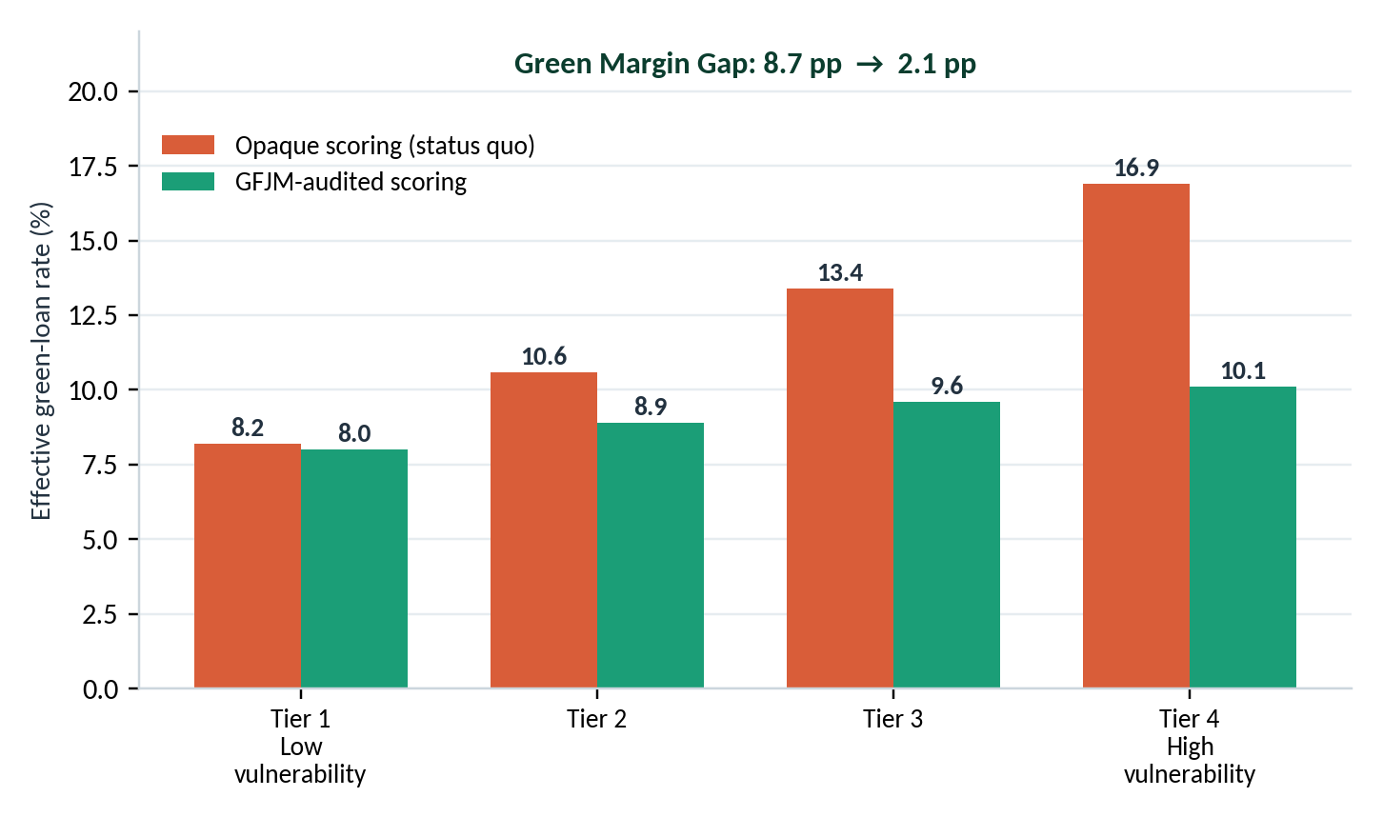

Figure 3. Effective green-loan rate by climate-vulnerability tier under opaque and GFJM-audited scoring. GMG = 16.9 − 8.2 = 8.7 pp (status quo) and 10.1 − 8.0 = 2.1 pp (GFJM).
Figure 3 effective green loan rate by climate-vulnerability tier under opaque and GFJM audited scoring percentage results, I have provided Github repository link.

Furthermore, the data indicate that the assumptions are not drawn from empirical datasets and may suggest that results should not be considered as significant empirical findings. Given that community audits could provide critical evidence, the first empirical test might examine difference-in-differences around introduction of audit or recourse rule. Analysis shows test could establish framework validity.

5.1 Six-Dimensional Governance Profile:
Dimension | Explicit definition | Relationship to Table 5
Community Voice (CV) | Degree to which affected communities participate in, influence, and can veto green-fintech model design and deployment | Primarily AGSS + Community Protocol Audit
Green-spread Parity (GSP) | Degree to which risk-adjusted green-finance pricing is comparable across climate-vulnerability groups | Inverse transformation of GMG
Credit Access Parity (CAP) | Degree to which approval/access rates are comparable between vulnerable and reference groups | Inverse transformation of CRI
Verified Impact (VI) | Degree to which the environmental impact financed by the system is verified relative to the resources/environmental footprint used | Related to CCR + verified-abatement component
Data Sovereignty (DS) | Degree to which communities retain ownership, governance, licensing rights and control over climate-related data | AGSS
Compute Frugality (CF) | Degree to which the model achieves its green-finance function with a relatively low lifecycle computational carbon footprint | Inverse transformation of CCR

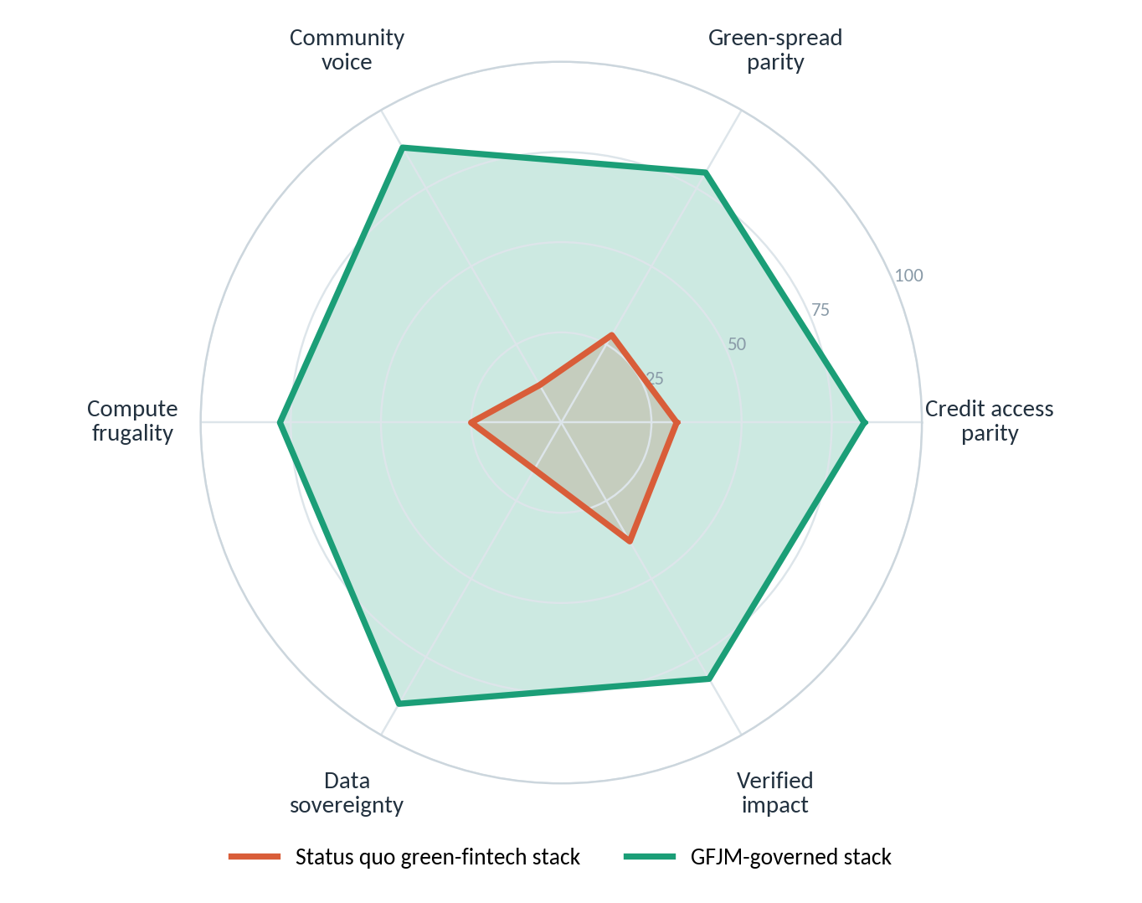
Figure 4. Six-dimension governance profile of a status quo versus a GFJM-governed green-fintech stack.
Figure 4 demonstrates that the broader governance profile may show important patterns across these key dimensions. Moreover, the largest illustrative gains could appear on community voice and data sovereignty specifically.
The six dimensions in Figure 4 form a second type of governance-profile visualization, namely, derived from the four GFJM indices and their respective governance components. As the present study is conceptual in nature, the respective numerical values are illustrative assigned scores and not empirical estimates.
I’m consistent with your own statement that they are illustrative assumptions numerical examples and are not empirical.
5.2 Calculating the scores on all six dimensions on a scale of 0-100:
A. Green spread parity
GMG = R _{high} – R _{low}
Where R is the risk adjusted effective Green loan rate. Higher GMG means higher injustice, you should reverse the direction when displaying it as a positive governance score:
GSP = 100*(1-GMG/GMG _{max)}
where GMG _{max} is the reference spread chosen for the scoring framework.
So:
Lower GMG → higher GSP
GMG = 0 → perfect parity →100
GMG as a 0 percentage points = parity; higher values = greater double – margin penality.
B. Credit Access Parity:
CRI = 1 – Approval _{vulnerable}
Approval _{reference}
Therefore,
CAP = 100(1-CRI)
Thus:
CRI = 0 → CAP = 100
CRI = 1 → CAP = 0
Table 5 already defines CRI between 0 &1.

C. compute Fragality:
CCR = Lifecycle kgCO2e of model
tCO2e of verified abatement
Lower CCR is better.
Therefore, for figure 4 need to normalize and reverse it:
CF = 100*(1-CCR-CCR_{min}
CCR_{max} - CCR_{min}
This produces;
Lowest CCR →100
Highest CCR → 0
D. Data Sovergenity and community voice:
Algorithmic Green Sovergenity Score (AGSS) = DO+BV+AR+LOI
4
Where
DO = Data ownership
BV = Binding veto
AR = Algorithmic recourse
LOI = Local oncology inclusion
All the scores are from 0 to 100.
Data Sovergenity Use: Data Sovergenity (DS) = Data ownership (DO)
Community voice use:
Community voice (CV) = BV+AR+LOI
3
E. Verified Impact (VI):
CCR = Model emissions
Verified abatement
Therefore, verified abatement is present in CCR, but verified impact itself isn’t a separate table 5 is
Verified Impact (VI) = 100*verified abatement
Target/reference abatement
Illustrative scoring of the six governance dimensions
Dimension | Status quo | GFJM governed | Scoring basis
Community Voice | 35 | 85 | AGSS governance components
Green-spread Parity | 35 | 85 | Normalized inverse GMG
Credit Access Parity | 30 | 85 | 100(1-CRI)
Verified Impact | 40 | 80 | Verified-abatement performance
Data Sovereignty | 25 | 90 | AGSS data-ownership component
Compute Frugality | 30 | 85 | Normalized inverse CCR

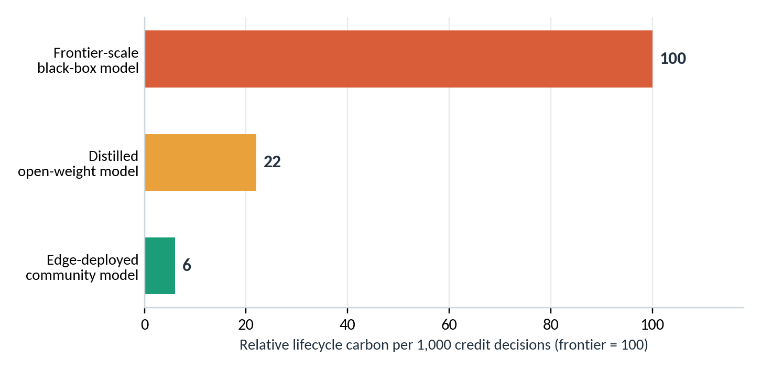
Figure 5. Illustrative Relative lifecycle carbon per 1,000 credit decisions by model architecture (frontier = 100).
Figure 5 (carbon per 1,000 decisions by model) has collected the sources from Strubell et al. (2019), Luccioni et al. (2023), Patterson et al. (2021), the ML.ENERGY leaderboard, IEA’s Energy and AI report, and de Vries-Gao (2025).
Furthermore, these findings suggest that the two dimensions represent areas where technical fairness fixes rarely provide meaningful change. Given that technical approaches demonstrate limitations, the results might indicate that governance mechanisms could address these critical gaps more effectively.

6. Case Scenarios: Redesigning Green-Fintech Systems
The scenarios appear to provide that illustrative design examples rather than observed implementations. Moreover, the scenarios may demonstrate that potential governance redesign opportunities could exist and might require empirical evaluation.
Scenario | Status quo | GFJM intervention
A. Green credit for smallholders and MSMEs | Opaque climate-risk scores widen spreads for exposed farms; alternative data is harvested without return | Community-defined vulnerability and resilience indexes; green data trust with a reciprocity ledger; recourse for contested scores
B. Carbon-credit markets and digital MRV | Satellite and AI verification is proprietary; forest communities supply ground truth but receive little of the credit value | Community oracles co-verify outputs; binding benefit-sharing through the trust; published model carbon budget
C. Parametric climate insurance | Index triggers calibrated on urban or insured-asset data miss rural loss patterns; payouts are slow or denied | Pluriversal trigger design using local ontologies of loss; community audit before deployment; deterministic, open triggers

Table 6. Redesigning three green-fintech systems.

7. Research Agenda and Limitations:
Measurement: However, operationalizing the four indices might suggest that risk-adjusted lending data, lifecycle assessments of model stacks and community-validated sovereignty tests appear necessary. Given that frugal models may sacrifice some predictive accuracy, the appropriate accuracy-footprint frontier appears to demonstrate that normative choice remains necessary for affected communities, not only for modelers. Nevertheless, the governance risk could suggest that community bodies appear vulnerable to capture. Governance risk shows community bodies captured. Additionally, rotating membership, independent technical support and transparent funding may indicate that design necessities could exist. In light of these limitations, the quantitative evidence here might suggest that illustrative examples appear present, and the propositions remain untested.
Limitation 1 In terms of justice, the framework has a strongly normative orientation towards notions of distributive and procedural justice which may not be acceptable to policymakers and financial institutions.
Limitation 2 the community governance structure itself may be susceptible to elite capture, unequal representation, and institutional conflicts.
Limitation 3 GFJM has not been empirically evaluated in jurisdictions.
8. Conclusion: Towards Green Finance
The findings suggest that decarbonisation cannot be financed on terms that may deepen the exposure of those who contributed least to the crisis. Moreover, the evidence indicates that retrofitting green-fintech models with superficial fairness constraints might not interrupt the double margin. Nevertheless, the Green Fintech Justice Matrix could provide an alternative approach: the results demonstrate that treating marginality as enclosure appears relevant. In light of these findings, the data suggest that pairing every pillar with a mechanism and a measurable index could establish key outcomes. Results show participation strengthens accountability. However, the study may indicate that community participation and accountability mechanisms within climate-finance governance systems appear important. Furthermore, these systems could provide the evidence on which green value is certified. Thus, the findings suggest that if the algorithmic margin is reclaimed, green fintech might become an instrument of collective adaptation. Given that extraction represents another frontier, the evidence may demonstrate that this approach could establish a significant alternative.
Data Sources Availability:
To maintain complete transparency and reproducibility, all raw data, processed data and additional tables used to generate the figures in this manuscript have been exported and saved in an open access repository. Upon request, reviewers are encouraged to examine and audit the data at this address: [Provide GitHub Link]

References:
Bartlett, R., Morse, A., Stanton, R., & Wallace, N. (2022). Consumer-lending discrimination in the Fintech era. Journal of Financial Economics, 143(1), 30–56.
Berg, F., Kölbel, J. F., & Rigobon, R. (2022). Aggregate confusion: The divergence of ESG ratings. Review of Finance, 26(6), 1315–1344.
Carroll, S. R., Garba, I., Figueroa-Rodríguez, O. L., Holbrook, J., Lovett, R., Materechera, S., Parsons, M., Raseroka, K., Rodriguez-Lonebear, D., Rowe, R., Sara, R., Walker, J. D., Anderson, J., & Hudson, M. (2020). The CARE principles for Indigenous data governance. Data Science Journal, 19(1), Article 43.
Couldry, N., & Mejias, U. A. (2019). The costs of connection: How data is colonizing human life and appropriating it for capitalism. Stanford University Press.
De Vries-Gao, A. (2025). The carbon and water footprints of data centers and what this could mean for artificial intelligence. Patterns. †
Demirgüç-Kunt, A., Klapper, L., Singer, D., & Ansar, S. (2022). The Global Findex Database 2021: Financial inclusion, digital payments, and resilience in the age of COVID-19. World Bank.
Ensign, D., Friedler, S. A., Neville, S., Scheidegger, C., & Venkatasubramanian, S. (2018). Runaway feedback loops in predictive policing. Proceedings of Machine Learning Research, 81, 160–171.
Fazelpour, S., & Danks, D. (2021). Algorithmic bias: Senses, sources, solutions. Philosophy Compass, 16(8), Article e12760.
Fourcade, M., & Healy, K. (2017). Seeing like a market. Socio-Economic Review, 15(1), 9–29.
Fuster, A., Goldsmith-Pinkham, P., Ramadorai, T., & Walther, A. (2022). Predictably unequal? The effects of machine learning on credit markets. The Journal of Finance, 77(1), 5–47.
Islam, M. M. (2022). Distributive justice in global climate finance: Recipients’ climate vulnerability and the allocation of climate funds. Global Environmental Change, 73, Article 102475. †
Rothstein, R. (2017). The color of law: A forgotten history of how our government segregated America. Liveright.
Sadowski, J. (2019). When data is capital: Datafication, accumulation, and extraction. Big Data & Society, 6(1).
Venner, K., et al. (2024). The multi-scalar inequities of climate adaptation finance: A critical review. Current Climate Change Reports. †
West, T. A. P., Börner, J., Sills, E. O., & Kontoleon, A. (2020). Overstated carbon emission reductions from voluntary REDD+ projects in the Brazilian Amazon. Proceedings of the National Academy of Sciences, 117(39), 24188–24194.
Xiao, T., et al. (2025). Environmental impact and net-zero pathways for sustainable artificial intelligence servers in the USA. Nature Sustainability. †
Zuboff, S. (2019). The age of surveillance capitalism: The fight for a human future at the new frontier of power. PublicAffairs.
Akerlof, G. A. (1970). The market for “lemons”: Quality uncertainty and the market mechanism. Quarterly Journal of Economics, 84(3), 488-500.
Bracking, S. (2015). The anti-politics of climate finance: The creation and performance of the Green Climate Fund. Global Policy, 6(4), 337-345.
DiMaggio, P. J., & Powell, W. W. (1983). The iron cage revisited: Institutional isomorphism and collective rationality in organizational fields. American Sociological Review, 48(2), 147-160.
Freeman, R. E. (1984). Strategic management: A stakeholder approach. Pitman.
Meyer, J. W., & Rowan, B. (1977). Institutionalized organizations: Formal structure as myth and ceremony. American Journal of Sociology, 83(2), 340-363.
Mitchell, R. K., Agle, B. R., & Wood, D. J. (1997). Toward a theory of stakeholder identification and salience. Academy of Management Review, 22(4), 853-886.
Pfeffer, J., & Salancik, G. R. (1978). The external control of organizations. Harper & Row.
Roberts, J. T., & Parks, B. C. (2007). A climate of injustice. MIT Press.
Spence, M. (1973). Job market signaling. Quarterly Journal of Economics, 87(3), 355-374.
Stiglitz, J. E., & Weiss, A. (1981). Credit rationing in markets with imperfect information. American Economic Review, 71(3), 393-410.
Fricker, M. (2007). Epistemic injustice: Power and the ethics of knowing. Oxford University Press.
Mohamed, S., Png, M.-T., & Isaac, W. (2020). Decolonial AI: Decolonial theory as sociotechnical foresight in artificial intelligence. Philosophy & Technology, 33(4), 659-684. https://doi.org/10.1007/s13347-020-00405-8
Strubell, E., Ganesh, A., & McCallum, A. (2019). Energy and policy considerations for deep learning in NLP. In Proceedings of the 57th Annual Meeting of the Association for Computational Linguistics (pp. 3645-3650). Association for Computational Linguistics. https://doi.org/10.18653/v1/P19-1355
Meerabi,Syed Nagul(Meerabi et al., 2026), Venkateswara Kumar, K. S., Kishore Babu, B., & Nagaraja Kumari, T. (2026). Algorithmic stewardship for sustainable finance: Governing AI, ESG integrity, and green supply chains. Social Science Forum Journal, 10(10), 801–819.
CRI 2026 ranking and results: highlights Climate Risk Index 2026 | Germanwatch e.V.
The ND-GAIN Index 2026 measures countries’ vulnerability to climate change and their readiness to implement adaptation strategies. ND-GAIN Index
MFIN’s primary objective is to work towards the robust development of the microfinance sector. MFIN INDIA
Press release from Reserve Bank of India, credit to 41 banks and agriculture sector reports Bank credit growth in India accelerates in September 2026, with a surge in services and industry
NABARD DEPARTMENT OF ECONOMIC ANALYSIS AND RESEARCH NATIONAL BANK FOR AGRICULTURE AND RURAL DEVELOPMENT June 2026 pub_26372606161645418.pdf
NABARD rural economic conditions and sentiments survey,July 2026 pub_17072611357478493.pdf
Jobin, A., Ienca, M., & Vayena, E. (2019). The global landscape of AI ethics guidelines. Nature Machine Intelligence, 1(9), 389–399. https://doi.org/10.1038/s42256-019-0088-2
Taylor, L. (2017). What is data justice? The case for connecting digital rights and freedoms globally. Big Data & Society, 4(2). https://doi.org/10.1177/2053951717736335
Raji, I. D., Smart, A., White, R. N., Mitchell, M., Gebru, T., Hutchinson, B., Smith-Loud, J., Theron, D., & Barnes, P. (2020). Closing the AI accountability gap: Defining an end-to-end framework for internal algorithmic auditing. Proceedings of the 2020 Conference on Fairness, Accountability, and Transparency, 33–44. https://doi.org/10.1145/3351095.3372873
Delacroix, S., & Lawrence, N. D. (2019). Bottom-up data trusts: Disturbing the “one size fits all” approach to data governance. International Data Privacy Law, 9(4), 236–252. https://doi.org/10.1093/idpl/ipz014
Patterson, D., Gonzalez, J., Le, Q., Liang, C., Munguia, L.-M., Rothchild, D., So, D., Texier, M., & Dean, J. (2021). Carbon emissions and large neural network training. arXiv. https://doi.org/10.48550/arXiv.2104.10350
Luccioni, A. S., Viguier, S., & Ligozat, A.-L. (2023). Estimating the carbon footprint of BLOOM, a 176B parameter language model. Journal of Machine Learning Research, 24(253), 1–15. https://jmlr.org/papers/v24/23-0069.html
Ustun, B., Spangher, A., & Liu, Y. (2019). Actionable recourse in linear classification. Proceedings of the Conference on Fairness, Accountability, and Transparency, 10–19. https://doi.org/10.1145/3287560.3287566
Karimi, A.-H., Barthe, G., Schölkopf, B., & Valera, I. (2022). A survey of algorithmic recourse: Contrastive explanations and consequential recommendations. ACM Computing Surveys, 55(5), Article 95, 1–29. https://doi.org/10.1145/3527848
Lacoste, A., Luccioni, A., Schmidt, V., & Dandres, T. (2019). Quantifying the carbon emissions of machine learning. arXiv. https://doi.org/10.48550/arXiv.1910.09700

